CO6210

Leon Robinson

1917597

J75391

Design Thinking for Innovation

Contents

Introduction 2

What is Human Centred design? 2

Origins of human centred design 2

Life Cycle of Human Centred design. 3

Observe & Engage in Behaviour 3

Ideation 3

Prototype 3

Feedback 3

Integration 3

Application 3

What is ISO 9241-210 Ergonomics of Human-System Interaction 4

Conclusion 4

References 5

# Introduction

User experience (UX) is designed to be able to suit the needs of a target audience and help enhance the user experience making the process easier for all. This report will be exploring what human centred design is and how it is applied within the UX and day to day technology, software and companies. Another topic this report will be exploring is the ISO 9421-210 this is a part of the lifecycle of human centred design.

## What is Human Centred design?

“Also known as Human-Centred Design, it is based on a philosophy that empowers an individual or team to design products, services, systems, and experiences that address the core needs of those who experience a problem” (DC Design, 2017) Human centred design a tool that is used to help the thinking process and to target a suitable audience, being able to design multiple solution and ideas that is most suitable for the target audience’s needs, while overall making the process quick and effective. (DesignKit, Visted 2021)

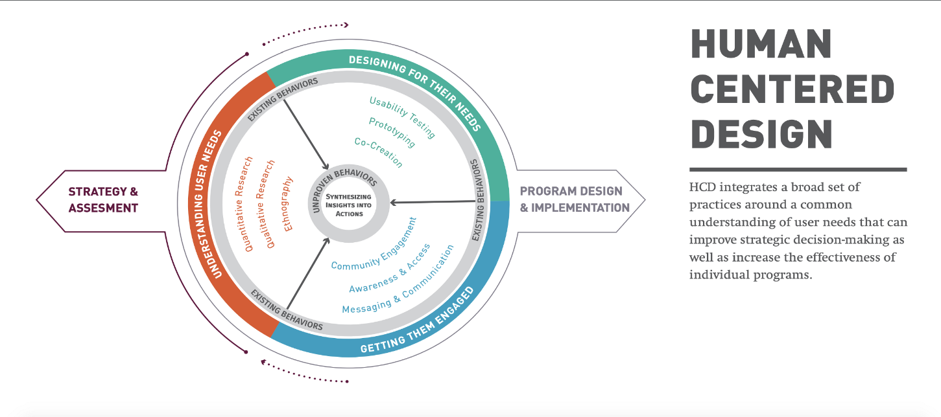

Figure 1 (Braga, 2019)

## Origins of human centred design

Human centred design can back backtrack over the 100 of years, this has been the bedrock for many concepts of sociology, cognitive psychology, ethnography, and engineering. Most recent events of Human-centred design can be traced back to the 1950’s from the help of Buckminster Fuller, he has described this as “…the effective application of the principles of science to the conscious design of our total environment in order to help make the Earth’s finite resources meet the needs of all humanity without disrupting the ecological processes of the planet”. (Nemeth, 2019)

Mike Cooley published, and book *Human-Centred System* and formulated the term “Haman-Centred Technology”, which got picked from different Professors David Kelly, Mike Nuttall, and Bill Moggridge who then created IDEO, this stared a new look into Human centred design which then only got more advanced, then in 2009 IDEO built a design kit to help teach the core concepts of Human centred design. To date Human centred design is used almost in every situation, regarding the means and focus of the needs of people. (Nemeth, 2019)

## Life Cycle of Human Centred design.

For the life cycle of Human centred design there are 6 steps to achieve an effective design with purpose.

### Observe & Engage in Behaviour

The first step that is needed to be taken is to learn as much information about the users end goal and to get involved and invested deeply into the people you are designing for lives, so that you can identify the key areas to that it can be catered to the user’s needs, this makes it easier near then end of the design by it being easier to find improvement and mistakes that could have been missed near the end of the design. (Voltage Control, 2020)

### Ideation

The next step is Ideation, this is the brainstorming phase, where all the potential ideas that can be thought of get written down, they can be either small or big, complex, or simple nothing is wrong at this stage, it all about getting all the ideas down so that problems and solutions can be seen early on, so they can be developed more to the user’s needs. (Voltage Control, 2020)

### Prototype

This step is where all the best ideas that have been thought become reality and is created into quick simplified prototypes, this is so all the ideas can be tested by the user, so that feedback can be given back about the idea, to see if the idea works for its targeting the audience. This is to make sure that everything is ok with the prototype before the actual version is made. (Voltage Control, 2020)

### Feedback

With the prototype made feedback can now be given, this stage all the prototypes have been made and is now going to be tested by the users to see if the idea works and is most suitable for them. What happens during the testing stages is seeing if the service was successful or failed to provide the needs of the users, the more feedback that is given the easier it is to pinpoint how suitable the work is for the design. (Voltage Control, 2020)

### Integration

With all the feedback given, we can see what is good and what is wrong with the designs, with the feedback improvements can now be made to the designs and wrongs can be corrected to suits the needs for the users, this can be done multiple times going back and forth from feedback to make sure the design is the most suitable and the best version of the design. (Voltage Control, 2020)

### Application

Lastly the application can be sent out to the world and seen by all, this isn’t the time to stop, more feedback will be sent back, and more improvement can be made, also the target audience could sway away from the original design so there is always more room for improvements. (Voltage Control, 2020)

## What is ISO 9241-210 Ergonomics of Human-System Interaction

ISO stands for “International Organization for Standardization, this is a standard worldwide and is used in all everyday tasks. being worldwide this is not a small organization the ISO has a network of over 160 national standard bodies. It is one of the biggest bodies in the world and is only gowning in numbers.” having created nearly 20,000 standards to date. ISO certification can be highly popular, with standards ranging from food safety to medical device requirements.” (Brooks, 2015)

ISO 9241-210 Human Systems Interaction focuses on the requirements and the recommendations of human centred design and only works for the life cycle of computer-based interactive systems. So, this doesn’t cover over other human centred designs problems such as health and safety and other issues, so the ISO had to create a multitude of different ISO 9241 so that can cover all bases of Human centred design. So, for this ISO 210 this covers the lifecycle of computer based on interactive systems, meaning the hardware and the software components to make the interactive processes of systems easier and can improve the use of interaction. (CEN, 2011)

# Conclusion

Human Centred Design has always surrounded us and will for the future it will always be able to help improve our way of life Physically and digitally and everyone’s ideas will change, with the advancements in the world and so will the design process “We can’t solve problems by using the same kind of thinking we used when we created them.”– Albert Einstein ( Parater, 2015)

# References

Parater, L. (2015, June 12). *10 quotes that will spark your design thinking*. Retrieved from UNHCR: https://www.unhcr.org/innovation/10-tweetable-quotes-that-will-spark-your-design-thinking/

Braga, J. (2019, July 15). *Is human-centered Design broken?* Retrieved from UX Collective: https://uxdesign.cc/is-human-centred-design-broken-cac130eecc48

Brooks, P. (2015, March 24). *What on Earth is ISO 9241?* Retrieved from UX Booth: https://www.uxbooth.com/articles/what-on-earth-is-iso-9241/

CEN. (2011). *Ergonomics of human-system interaction - Part 210: Humancentred design for interactive systems (ISO 9241-210:2010).* Slovenski: CEN.

DC Design. (2017, August 14). *What Is Human-Centered Design?* Retrieved from Medium: https://medium.com/dc-design/what-is-human-centered-design-6711c09e2779

DesignKit. (Visted 2021, November 22). *What is Human-Centerd-Design ?* Retrieved from DesignKit: https://www.designkit.org/human-centered-design

Nemeth, A. (2019, June 4). *An Introduction to Human-Centered Design*. Retrieved from MovingWorlds: https://blog.movingworlds.org/an-introduction-to-human-centered-design/

Voltage Control. (2020, March 26). *6 Phases of the Human-Centered Design Process*. Retrieved from VOLTAGE CONTORL: https://voltagecontrol.com/blog/6-phases-of-the-human-centered-design-process/